1. Under compute engine, go to Instance Template and click create instance template

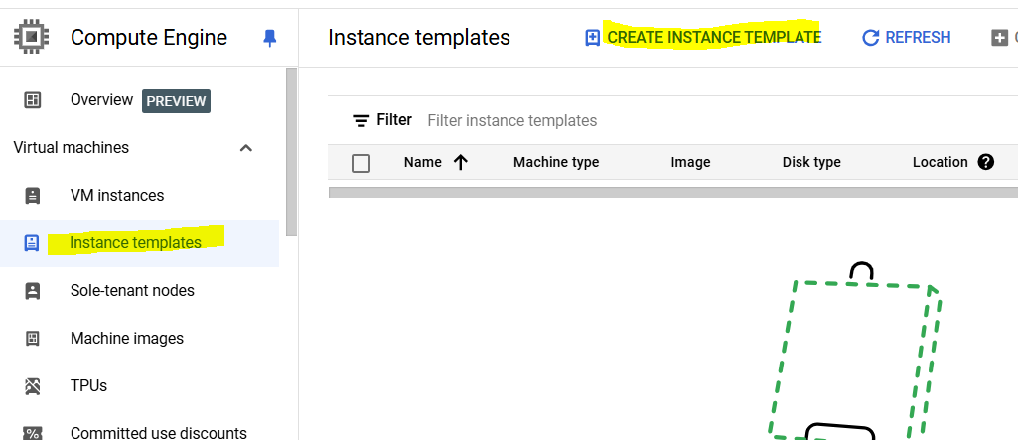

1. Give template a name, like my-arm-template, change location to Global

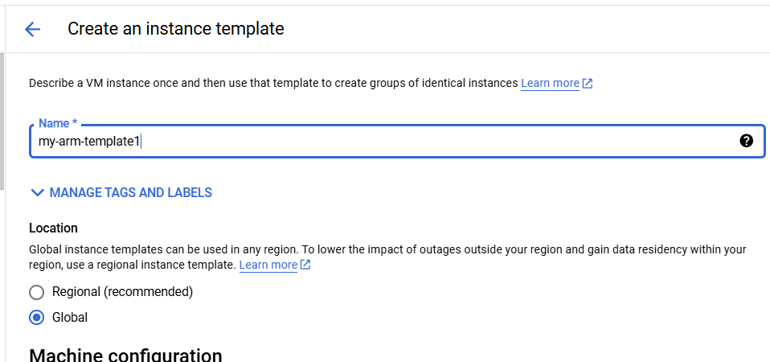

1. Change shape to T2A

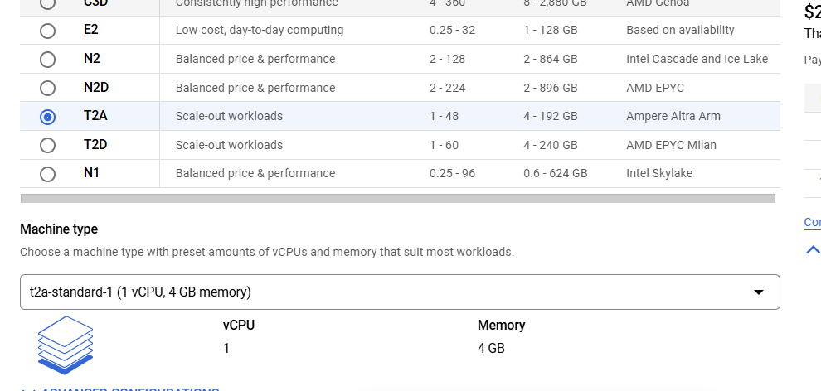

1. Change boot disk type to “New SSD persistent disk”
2. Keep rest all default and click create
3. Now we will create a Vm from this template, for this go to VM Instance page and click create instance

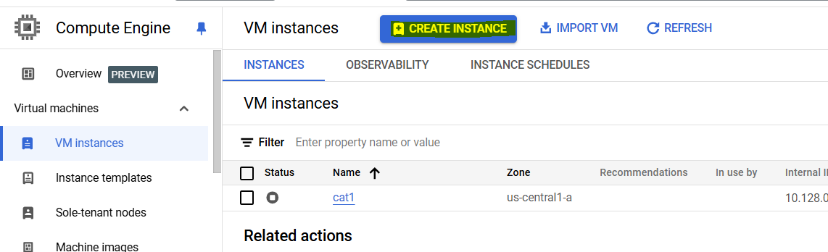

1. Click Create from option and select Instance templates

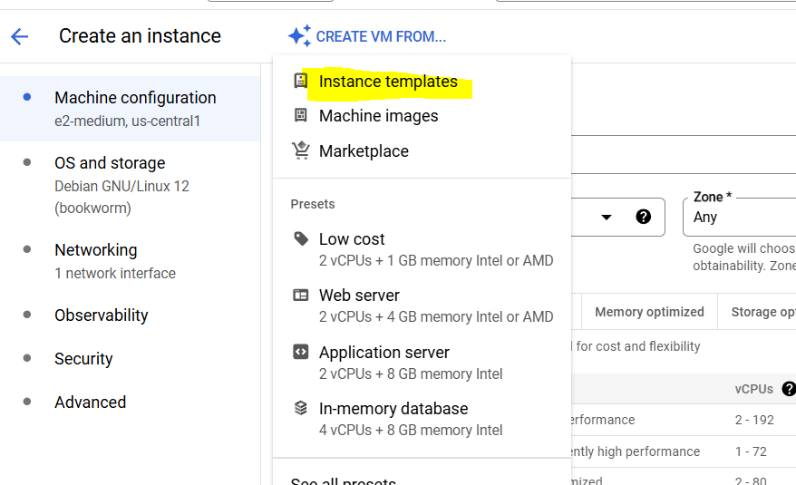

1. Select template which we created above and click customize

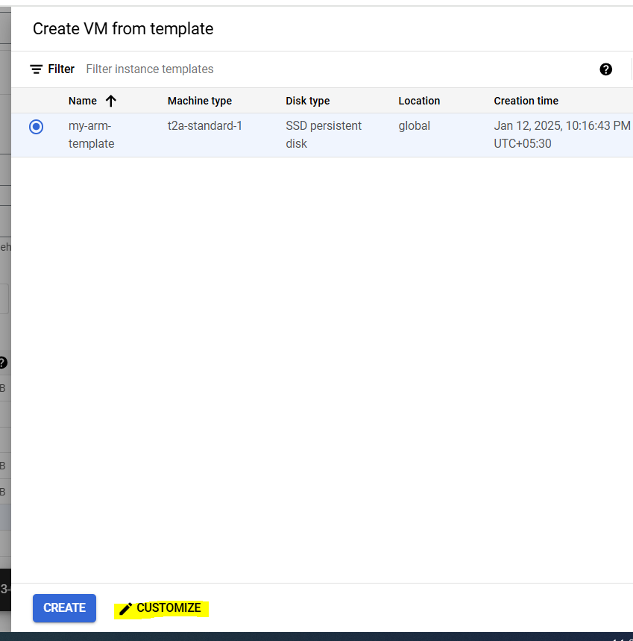

1. Update the name as per requirement, now if you will check, will find that all configurations like shape and boot volume type are same as we selected in template. Click create
2. VM is created as per details we provided

